

PROJECT PROPOSAL



Roof Protection System

|  |
| --- |
| **Prepared For**  **Andrew Whetsel**  939 Meade Street  Dunmore |

Date: October 31, 2025

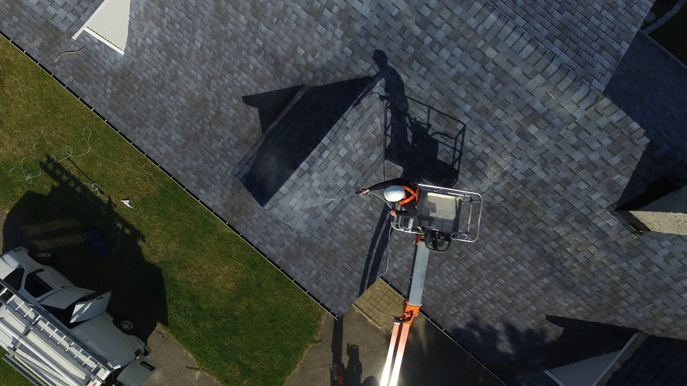

*Extending Roof Life with Advanced Nanotechnology*

myroofrecharge.com

**COMPANY PROFILE**

*Transforming roof protection with cutting-edge nanotechnology solutions across the Mid-Atlantic United States*

We believe that every property deserves protection that lasts. Our journey began with a commitment to bringing innovative nanotechnology solutions to property owners who demand excellence and longevity from their roofing investments.

**Our Experience**

Green Energy Construction & Consulting has over 15 years of experience developing and installing thousands of renewable energy projects for home and business owners. It is through this experience we recognized a clear need and our Roof Recharge division was born.

**Why We're Different**

We recognized that traditional roofing treatments offered short-term protection at best. We partnered with GoNano to deliver cutting-edge nanotechnology solutions that strengthen durability and extend roof lifespan by decades, providing our customers with true long-term value.

**Our Service Area**

Today, we serve property owners throughout the Mid-Atlantic United States, combining our construction expertise with revolutionary GoNano technology to protect investments and reduce maintenance costs for years to come.

**Our Commitment**

✓ Authorized GoNano Installer - Fully certified and trained in advanced application techniques

✓ Proven Track Record - Thousands of successful installations over 15+ years

✓ Long-Term Protection - Solutions that extend roof life by decades, not just years

✓ True Value - Cost-effective alternatives to premature roof replacement

**PROJECT DESCRIPTION**

|  |  |
| --- | --- |
| **Property Address** | 939 Meade Street, Dunmore |
| **Roof Area** | 5500 sq ft |
| **Roof Type** | Asphalt Shingle |
| **Roof Age** | 10 years |



**JOB PROCESS**

|  |  |  |  |  |
| --- | --- | --- | --- | --- |
| **STEP 1**  Roof Inspection | **→** | **STEP 2**  Product Ordering  & Scheduling | **→** | **STEP 3**  GoNano Installation  & Final Inspection |

**Proposed GoNano Solution**

|  |  |
| --- | --- |
| Based on our inspection and analysis of your roof, we recommend:  **GoNano Revive**  *Ideal for mid-life roofs (8-15 years old), this advanced formula rejuvenates aging shingles and restores protective properties.* |  |

**Product Overview**

GoNano Revive is a nanotechnology-based rejuvenation system for aging asphalt shingles. The advanced formula penetrates deep into shingle material, restoring flexibility and creating a protective barrier against further deterioration.

|  |  |
| --- | --- |
| **KEY FEATURES** | **PROVEN RESULTS** |
| **✓ RESTORE** Rejuvenates aging shingles  **✓ PROTECT** Creates long-lasting barrier  **✓ PRESERVE** Prevents further deterioration  **✓ LONGEVITY** Extends roof life 8-12 years | • Restores shingle flexibility  • Fills micro-cracks and gaps  • 100% breathable protection  • Improves water resistance  • Natural flat finish  • UL & IBHS tested  • 5-15 year warranty |

**Additional Notes:** Customer's mid-life roof will benefit from GoNano Revive's restoration properties, filling micro-cracks and rejuvenating aged shingles for extended protection.

**THE GONANO DIFFERENCE**

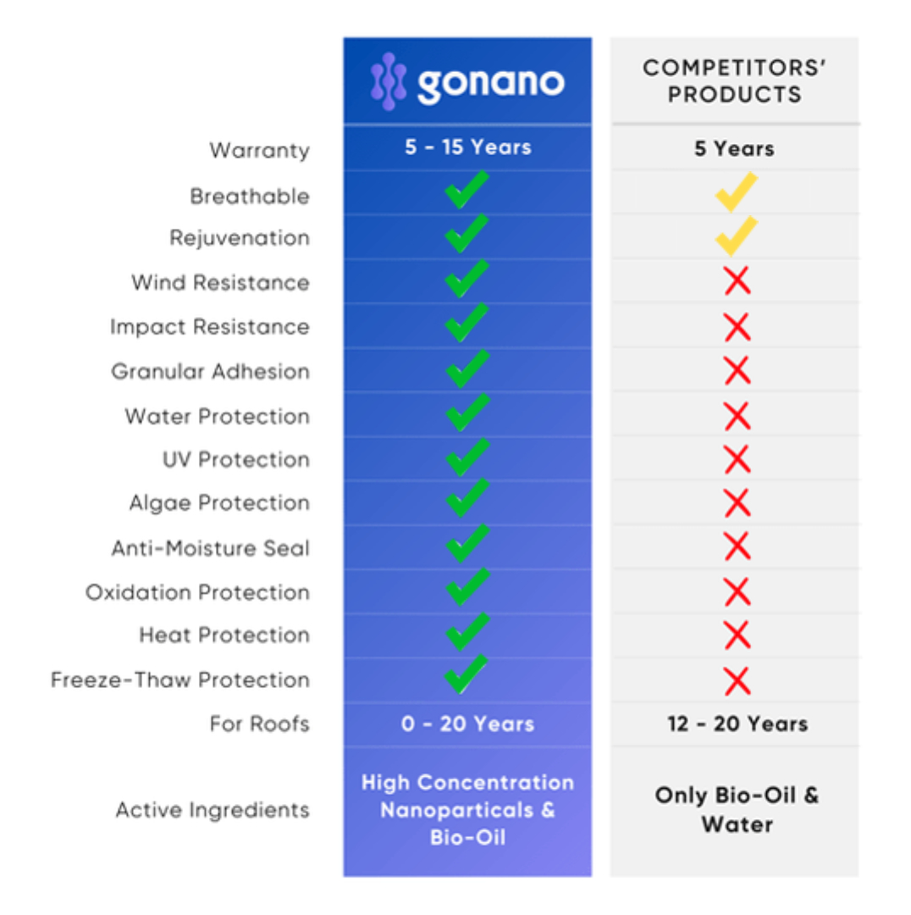

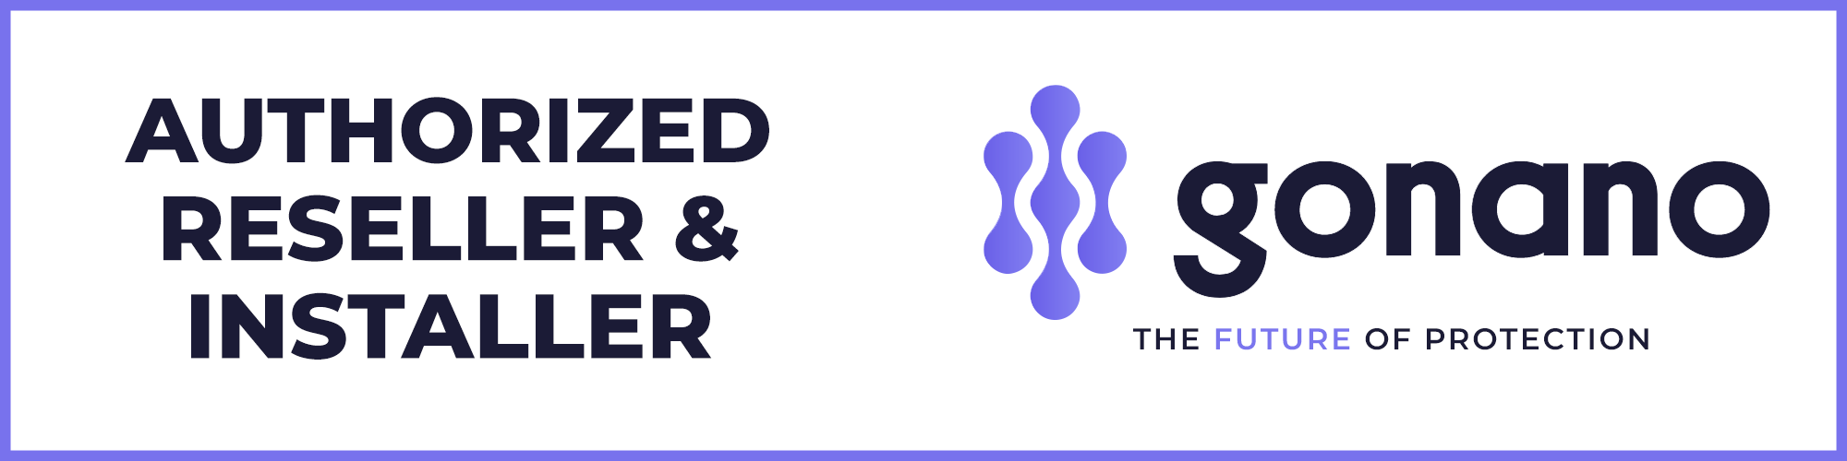

**INVESTMENT & SAVINGS ANALYSIS**

|  |  |
| --- | --- |
| **Description** | **Amount** |
| GoNano Saver Application (5500 sq ft) | $14300.00 |
| Professional Installation | $400.00 |
| **Total Investment** | **$14700.00** |

**Cost Comparison**

|  |  |
| --- | --- |
| **Full Roof Replacement**  *(Typical cost: $8.50/sq ft)* | **$46750.00** |
| **GoNano Protection** | **$14700.00** |
| **Your Savings:** | **$32050.00** |

**AUTHORIZATION TO PROCEED**

By signing below, you authorize Roof Recharge by Green Energy Construction & Consulting to proceed with the GoNano application as outlined in this proposal.

_______________________________

Customer Signature

_______________________________

Customer Name (Print)

_______________________________

Date

_______________________________

Eat Nuts

_______________________________

Date

**TERMS AND CONDITIONS**

**1. SCOPE OF WORK**

Roof Recharge will apply GoNano nanotechnology protection to the specified roof area. This includes roof inspection, cleaning as necessary, and professional application of the GoNano product.

**2. WARRANTY**

GoNano products are warranted for 10-15 years depending on roof condition. This warranty covers the performance of the GoNano coating and does not void existing shingle manufacturer warranties.

**3. PAYMENT TERMS**

Payment is due upon completion of application. We accept cash, check, and major credit cards.

**4. WEATHER CONDITIONS**

Application requires dry conditions. If weather prevents application, we will reschedule at the earliest convenient time.

**5. LIABILITY**

Roof Recharge and GoNano are not responsible for pre-existing roof conditions or damage. Our inspection will identify any issues that may affect warranty coverage.

**6. ENVIRONMENTAL SAFETY**

GoNano products are environmentally friendly with no harmful chemicals. The products are safe for vegetation, animals, and humans.

**7. ADDITIONAL FEES**

Additional fees may apply for structural changes, shingle replacements, or specialized installation equipment such as boom trucks. Any such additional costs will be discussed and approved before work proceeds.